**Installation instructions of Arduino IDE is shown in the following picture:**

Note: The following are the Windows user installation steps, Mac OS X users need to download the installation package to install.

The official website address :<http://www.arduino.org.cn/software>

1.You need to open setup package to find **arduino-1.7.8.org-windows.exe.**

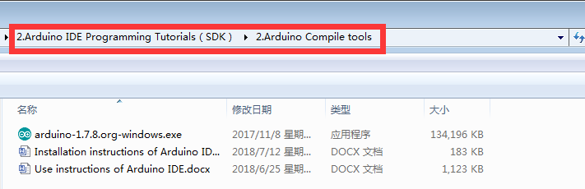

2.You need to double click to open the installation package **arduino-1.7.8.org-windows.exe.**

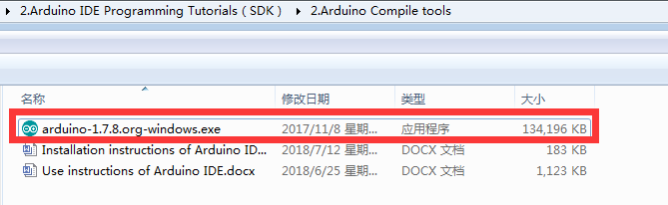

3.You need to click **I Agree,** as shown in the following picture.

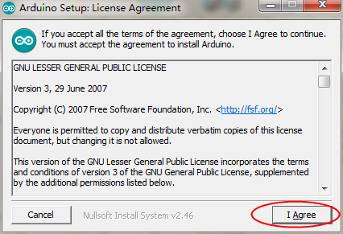

4. You need to click **Next,** as shown in the following picture.

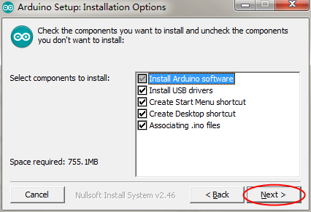

5.You need to choose an installation path, as shown in the following picture.(just an example)

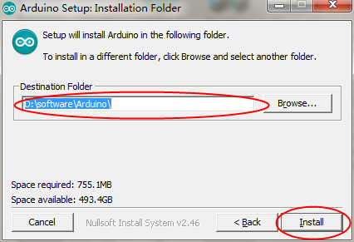

1. You need to wait for the progress bar to complete. The operation is as shown below.

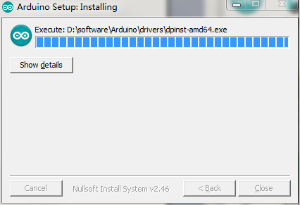

7.You need to click bottom right corner, as shown in the following picture.

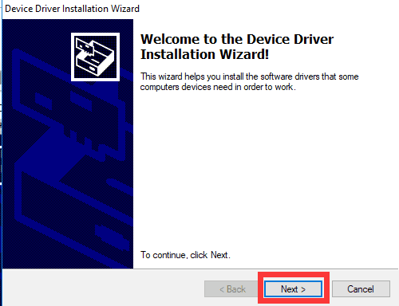

8.You need to click bottom right corner, as shown in the following picture.

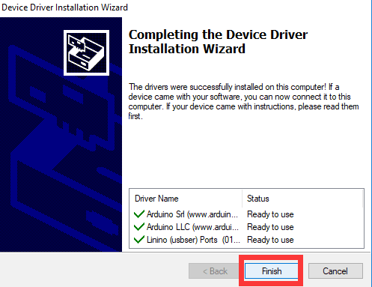

After the steps above, the Arduino IDE is installed successfully.